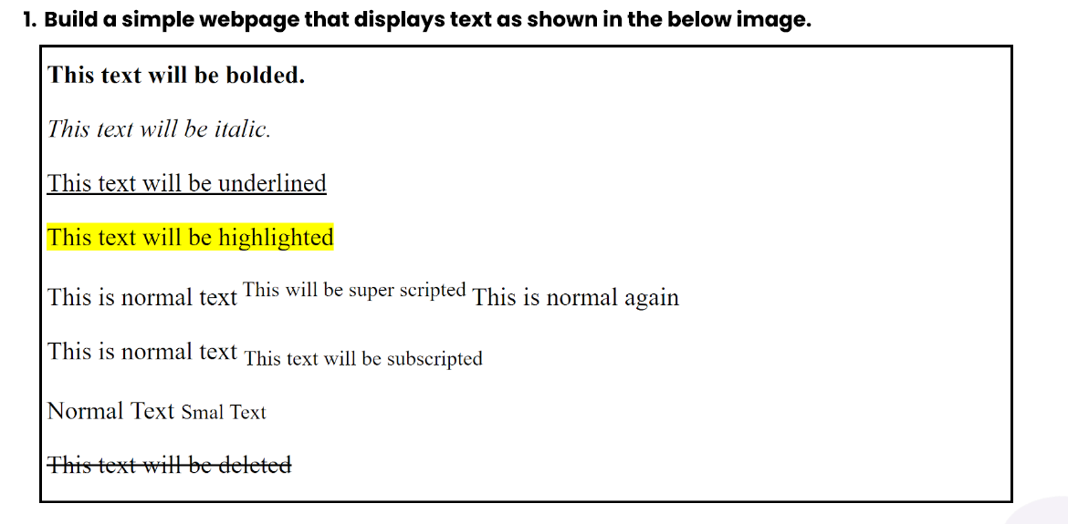

**Ans)** [Code of Question 1](https://github.com/Siddhant-Kumar-04/FullStack-Web-Developement/blob/512713408cf48fa56e67546ae629865e21fcbf8b/Module%204/Assignment%20Question/Questio_1.html)

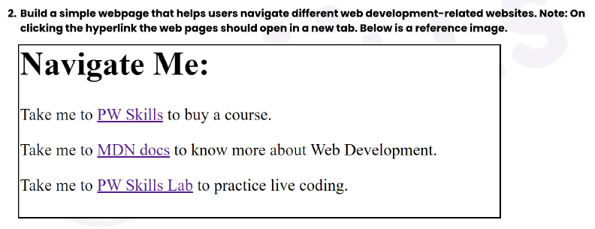

[Ans)Code for Question 2](https://github.com/Siddhant-Kumar-04/FullStack-Web-Developement/blob/512713408cf48fa56e67546ae629865e21fcbf8b/Module%204/Assignment%20Question/Question_2.html)

**Q3)Build a simple blog web page with 3 pages home, web development, and web design. Each page must contain hyperlinks to other pages in the top, a heading of the page topic and a paragraph of information. For the home page you can add some information about your self.**

**Ans)**

* [Home_Page](https://github.com/Siddhant-Kumar-04/FullStack-Web-Developement/blob/512713408cf48fa56e67546ae629865e21fcbf8b/Module%204/Assignment%20Question/Question_3_Home.html)
* [Web Development](https://github.com/Siddhant-Kumar-04/FullStack-Web-Developement/blob/512713408cf48fa56e67546ae629865e21fcbf8b/Module%204/Assignment%20Question/Question3_Web_Developement.html)
* [Web Design](https://github.com/Siddhant-Kumar-04/FullStack-Web-Developement/blob/512713408cf48fa56e67546ae629865e21fcbf8b/Module%204/Assignment%20Question/Question3_Web_Design.html)

**Q4)** **Create an ordered list of HTML tags. Each list item must include the tag name and some information about the tag.**

Ans) [Code of Question 4](https://github.com/Siddhant-Kumar-04/FullStack-Web-Developement/blob/512713408cf48fa56e67546ae629865e21fcbf8b/Module%204/Assignment%20Question/Question_4.html)

**Q5) Create a description list of full stack web development tech stack, using the <dl> tag. Each term should be a tech stack name and each description should be a brief explanation of what the tech stack is used for.**

Ans) [Code of Question 5](https://github.com/Siddhant-Kumar-04/FullStack-Web-Developement/blob/512713408cf48fa56e67546ae629865e21fcbf8b/Module%204/Assignment%20Question/Question_5.html)

**Q6)** **Create an ordered list of the full stack web development tech stack HTML, CSS, and JS. For each tech stack, create a table that lists the tech stack name, its primary use cases, and some key features or benefits. Below is a reference image.**

Ans) [Code of Question 6](https://github.com/Siddhant-Kumar-04/FullStack-Web-Developement/blob/512713408cf48fa56e67546ae629865e21fcbf8b/Module%204/Assignment%20Question/Question_6.html)

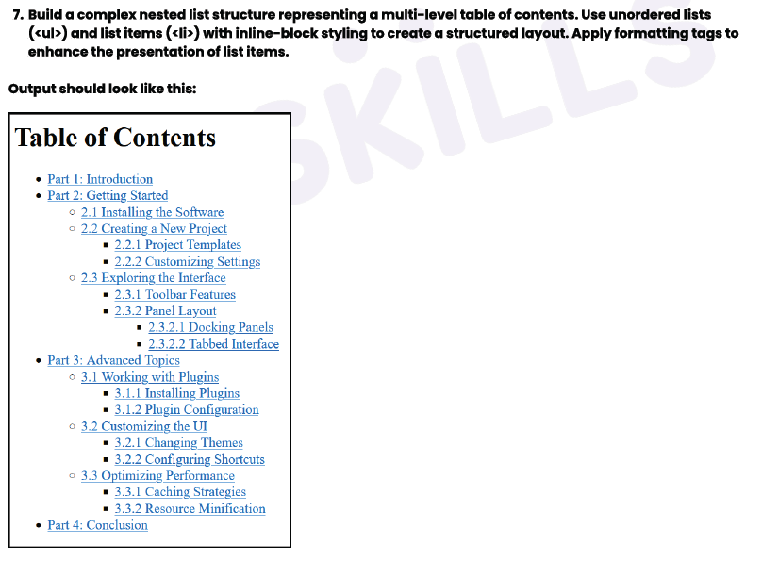

Ans) [Code of 7th Question](https://github.com/Siddhant-Kumar-04/FullStack-Web-Developement/blob/512713408cf48fa56e67546ae629865e21fcbf8b/Module%204/Assignment%20Question/Question_7.html)

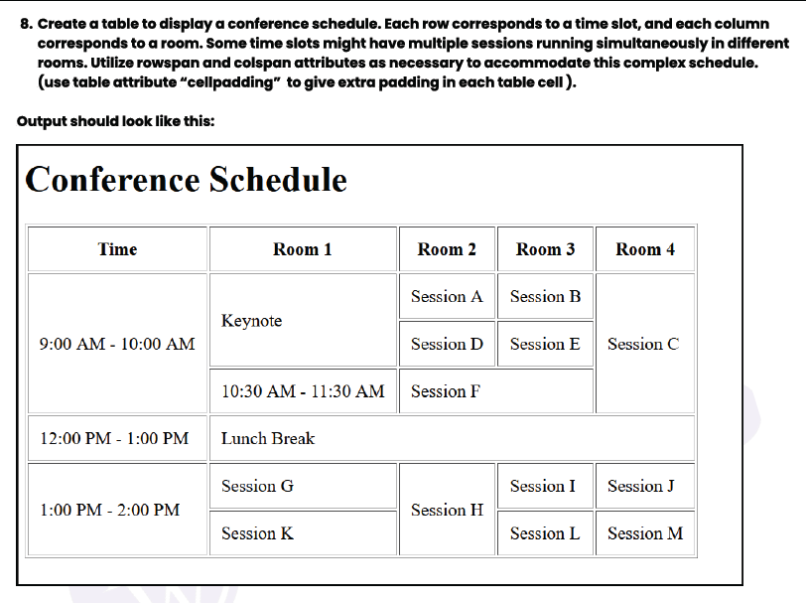

Ans) [Code of Question 8](https://github.com/Siddhant-Kumar-04/FullStack-Web-Developement/blob/512713408cf48fa56e67546ae629865e21fcbf8b/Module%204/Assignment%20Question/Question_8.html)